Between 2004 and 2006 Zoo World Ministries contributed $2,000 towards the $6,000 purchase price for the land that was to become Village of Hope. This was very meaningful to us, as this was the period when we had nothing but “dirt, a dream, and a calling.”

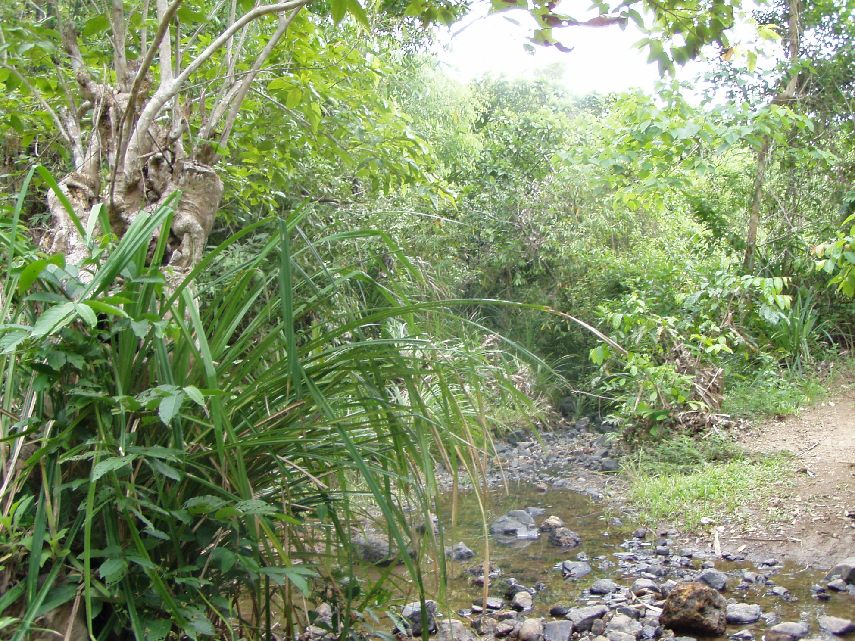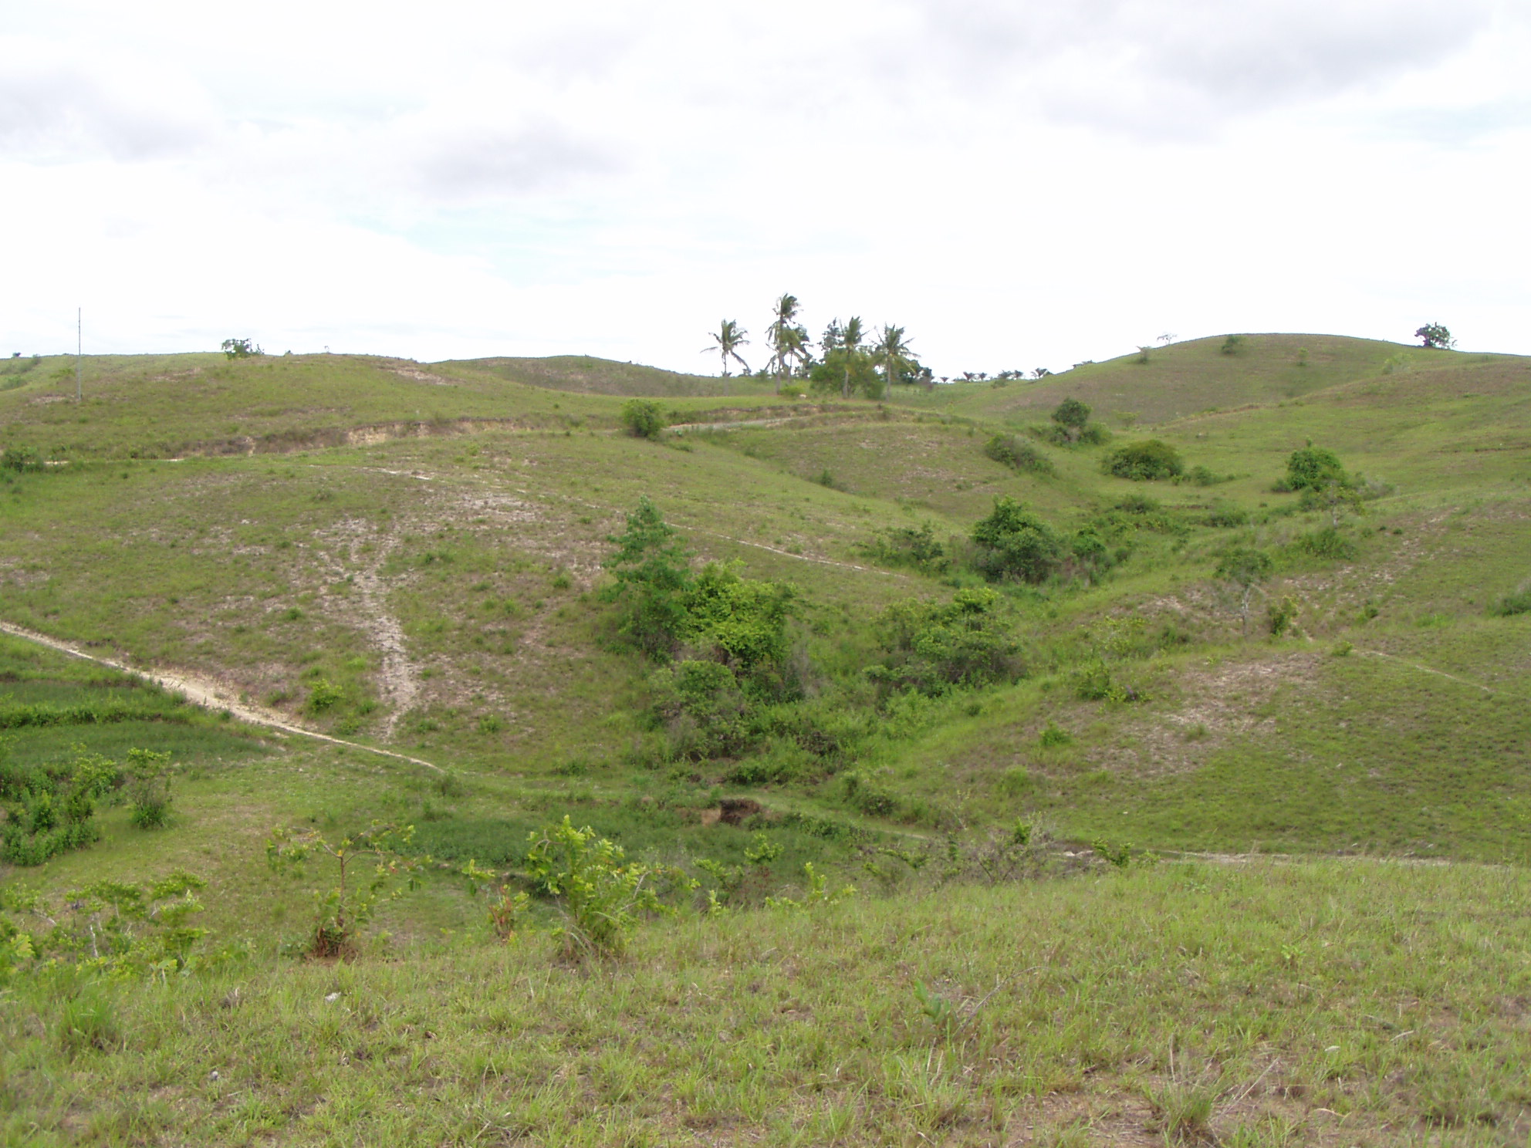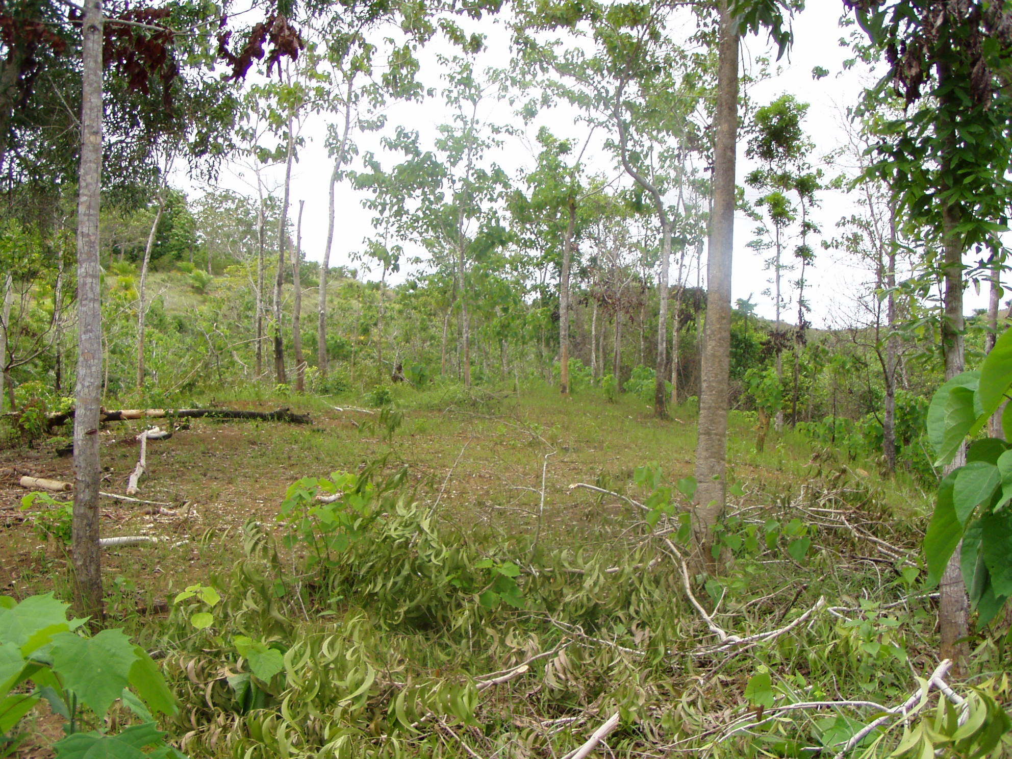
How Village of Hope looked when Zoo World Ministries first partnered with us in
providing hope for orphaned, abandoned and abused children in the Philippines

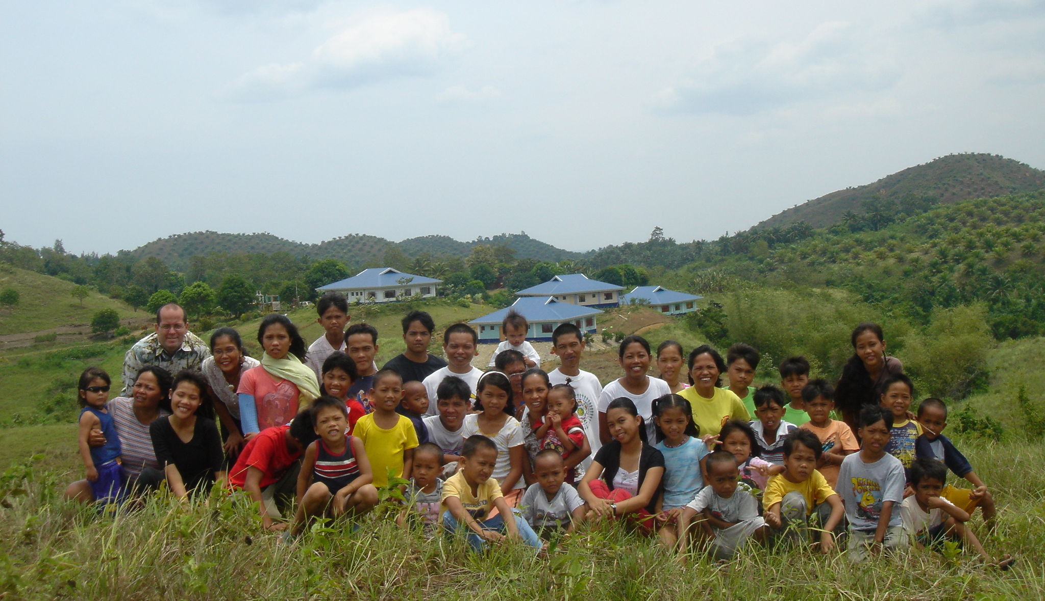
Today Village of Hope has four Homes and provides Christian
families to forty-five children. On this property will rise
sixteen more homes, allowing us to minister to 200 children.

In 2012 Zoo World Ministries gifted Village of Hope with $1,500 to help us minister to the orphans in our care and to work to spread the Gospel throughout the southern Philippines. In 2014, on two separate occasions, Zoo World Ministries gave us $500 on two separate occasions. This helped us minister to survivors of a record-setting typhoon and a record-setting earthquake. From those efforts, thousands of people were ministered to, twenty tons of relief goods were distributed, 42 homes have been built, multiple churches have been started, and more than 125 people have begun a saving relationship with Jesus.

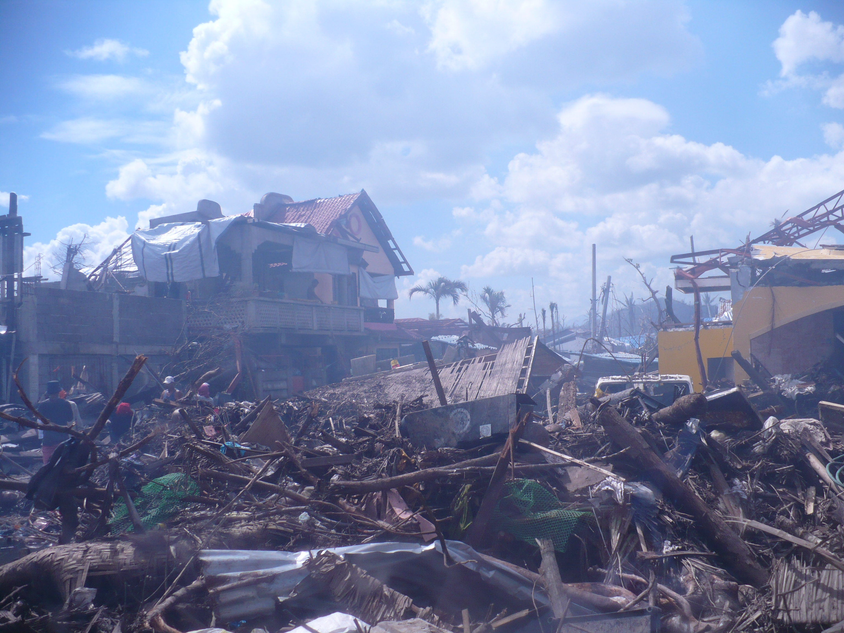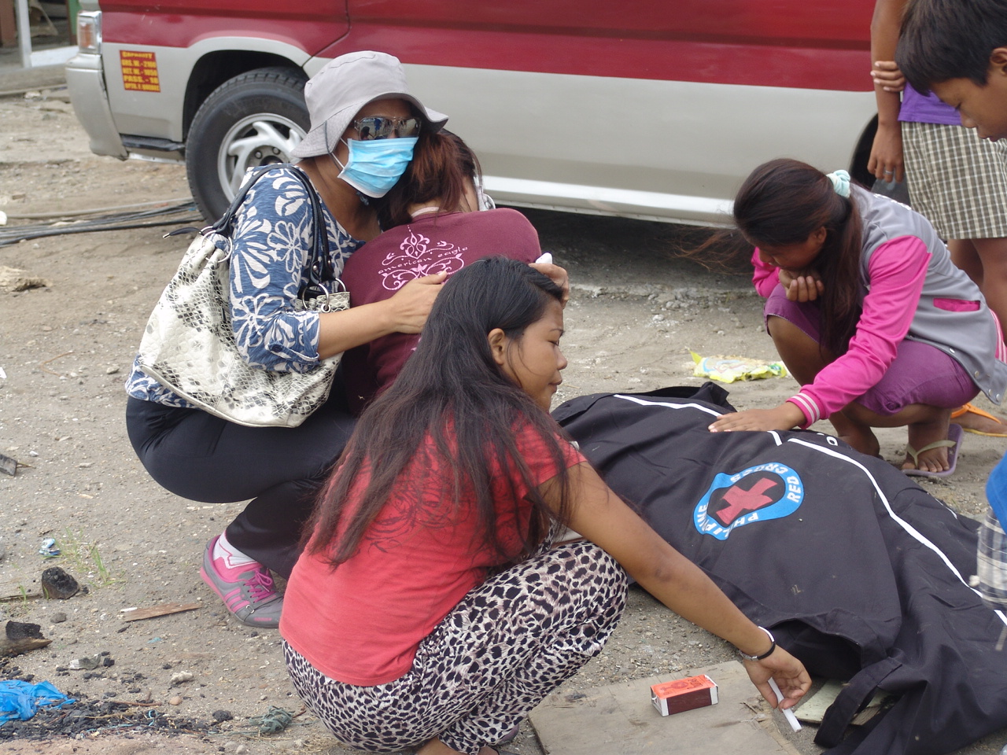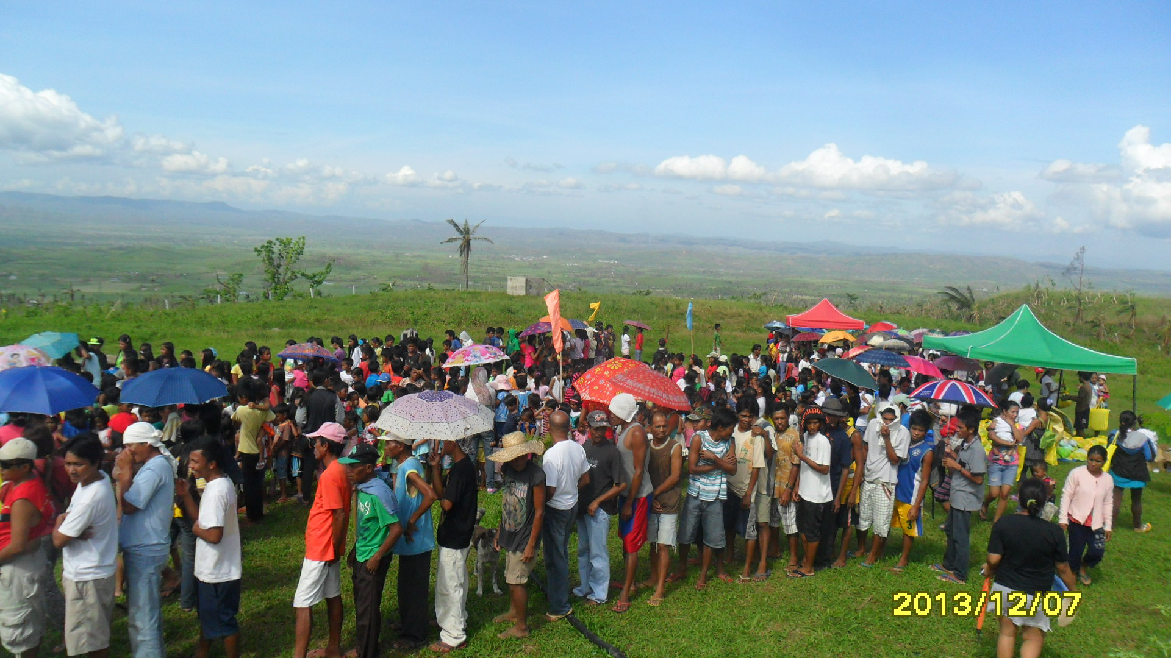
Last year’s series of natural disasters took tens-of-thousands of lives and destroyed entire communities. In
His perfect plan God is making beauty from these ashes and introducing people to a love-relationship with
their Creator. Through the generosity of family, friends, and organizations like Zoo World Ministries we were able to provide water, food, clothes, shelter, medical aid and spiritual counsel to thousands suddenly living in their worst time need.

We are looking at three projects that would be great areas for Zoo World Ministries to partner with us:
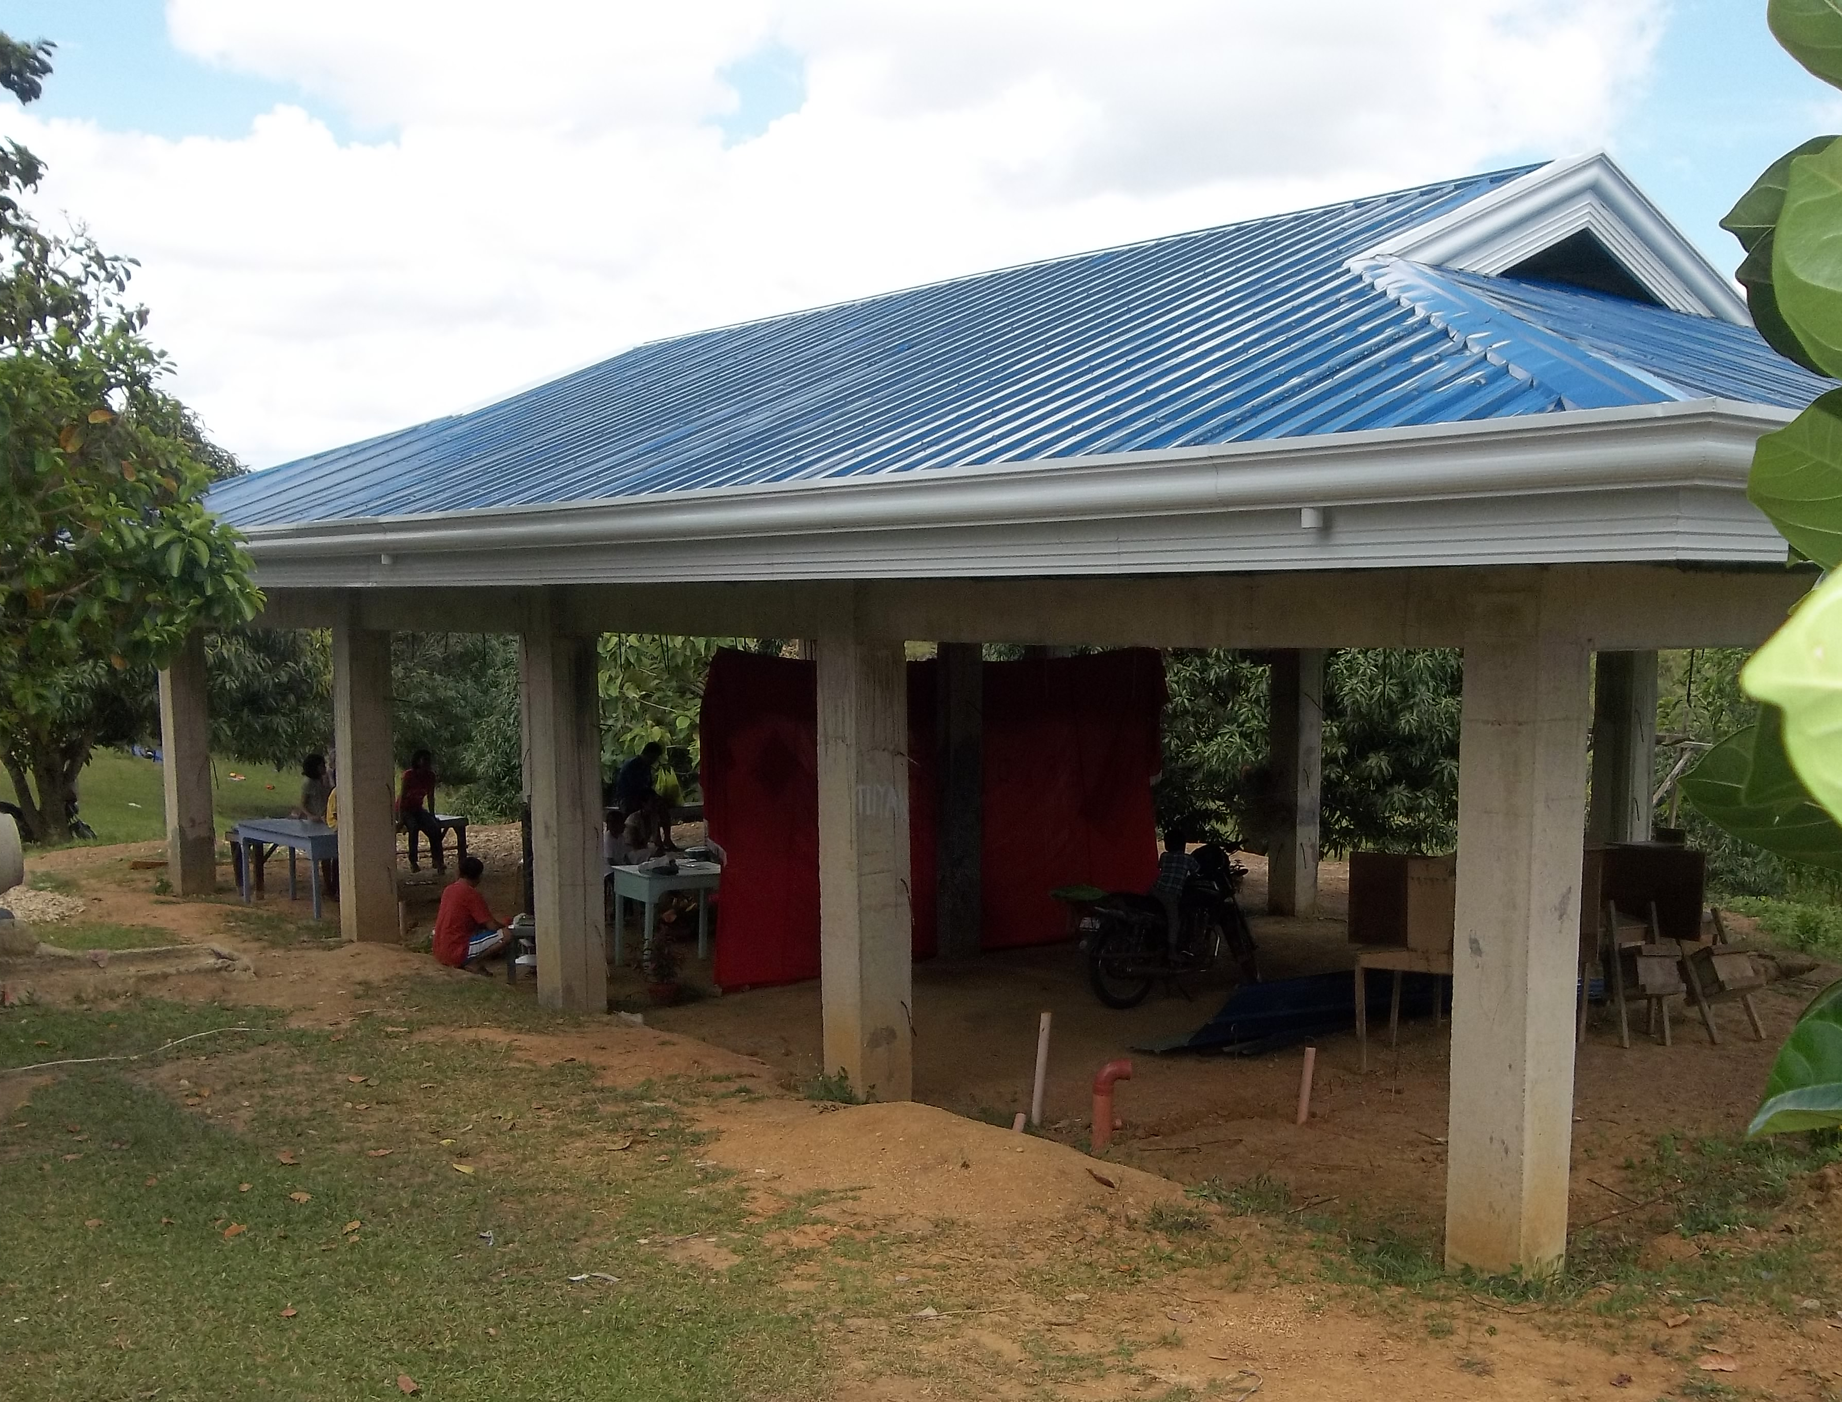
Completion of Village of Hope’s Educational and Guest Lodging Building
In 2013 we began construction on a building that would provide a 625 square foot educational room for educating our younger children. The building also has a 625 square-foot apartment for visitors. The beams, roof and in-ground plumbing are in place. An estimated $7,500 would finish this project, providing for the floor, walls, electrical and interior developments for this project.

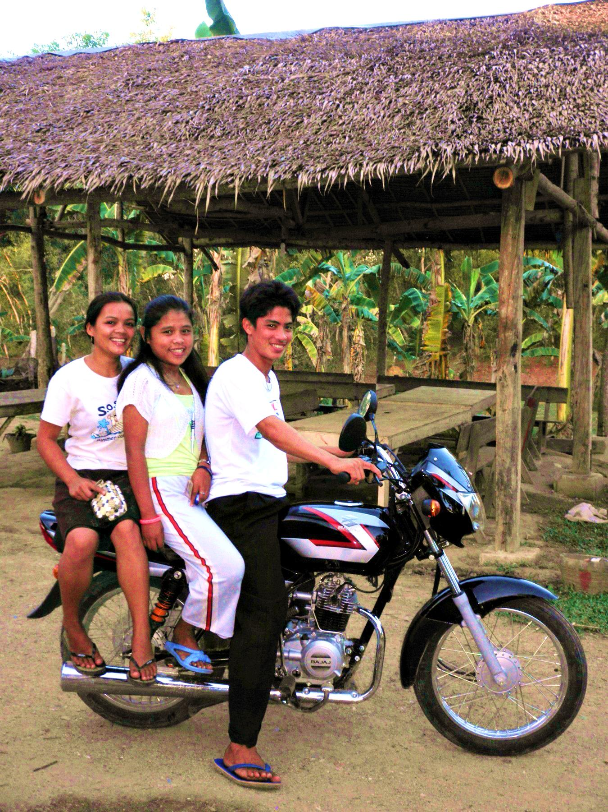
Ministry Motorbikes
Motorbikes are the primary means of family transportation on Bohol. They can take our evangelism and church planting teams into the mountains and even on boats to smaller islands. Depending on terrain, we will use 100cc or 125cc bikes to take a ministry team of two-to-five people, along with their ministry equipment to communities that would otherwise have no Gospel witness. Also, Village of Hope uses bikes like these to move our Kids to and from church, to and from school (on days to rainy for the Kids to walk), and for family trips to the market. With recent expansion to the ministry we have an immediate need for three bikes, and more would always be useful. The smaller bikes (not meant for mountains) start at $1,400; the larger bikes $1,900.
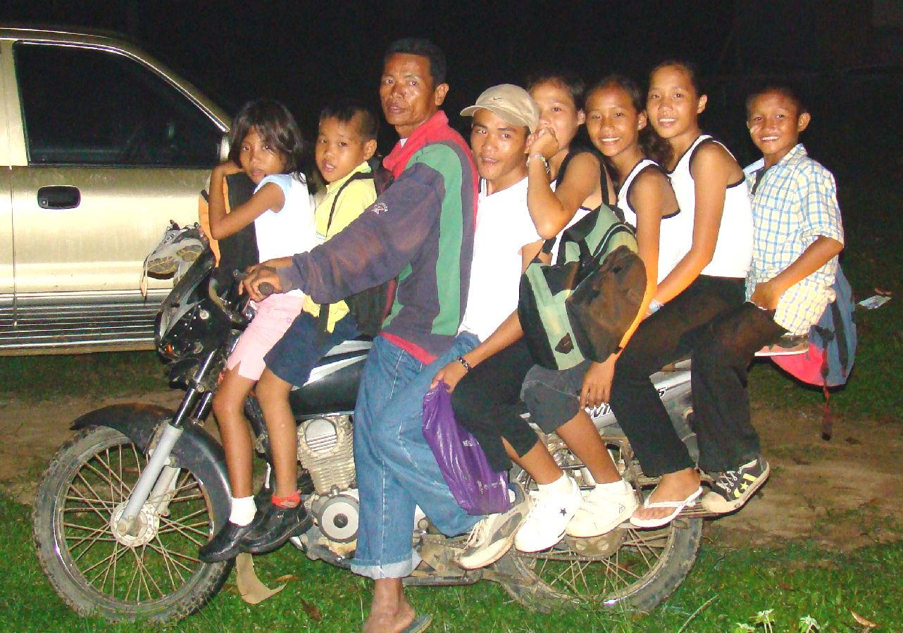
Two months ago one of our orphanage staff members was driving one of our bikes to the orphanage. When turning from the highway he was struck by an ambulance and killed, and the bike was destroyed. Since then many of our evangelism team members have had an unhealthy amount of fear associated with riding these bikes, and it is affecting the ministry. Please join us in praying that this spirit of fear be broken, and the Gospel continues to go forward without fear and with nothing less than success in changing lives forever.

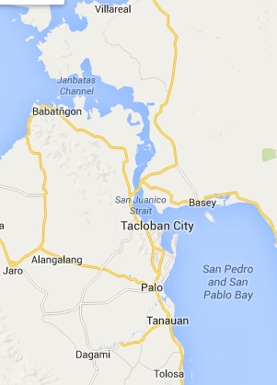
Village of Hope Samar
Samar province is home of the Waray people, a tribal group of more than three million yet one of the least-reached peoples in the Philippines; less than one percent of the Waray are born again. Many missionaries have burned out and saw little success after years of working in Samar. Samar was also the first place Typhoon Haiyan touched down in the Philippines. Many orphans were left behind. We feel called to open a second Village of Hope in Samar. Not only will this second Village of Hope minister to the needs of orphaned, abandoned and abused children in and around Samar, but we truly believe that in the same way Village of Hope in Bohol has opened incredible doors to the Gospel, that God can use Village of Hope Samar to open doors for ministry among a people group that has greatly resisted the Gospel. Also, the House Dad in Village of Hope’s Home 4 is Waray, and he is excited at the thought of moving his family to Samar, to serve as our first House Parents at this second Village of Hope. We have not yet scouted the land that will become this second Village of Hope. We are estimating $35,000 for the land and the infrastructure needed to make it ready for construction (internal water, electric, roads and sanitation) and $35,000 per Home on the property, or $175,000 to acquire land and build four Homes on the property.

